
DIGITAL ASSIGNMENT 2

Name: Soumyadeep Ganguly
Reg No: 24MDT0082
Course: Big Data Analytics Lab
Course Code: PMDS507P

Step 1: Check java version
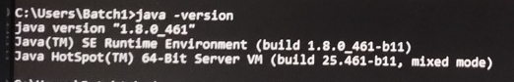

Step 2: Check Hadoop version
